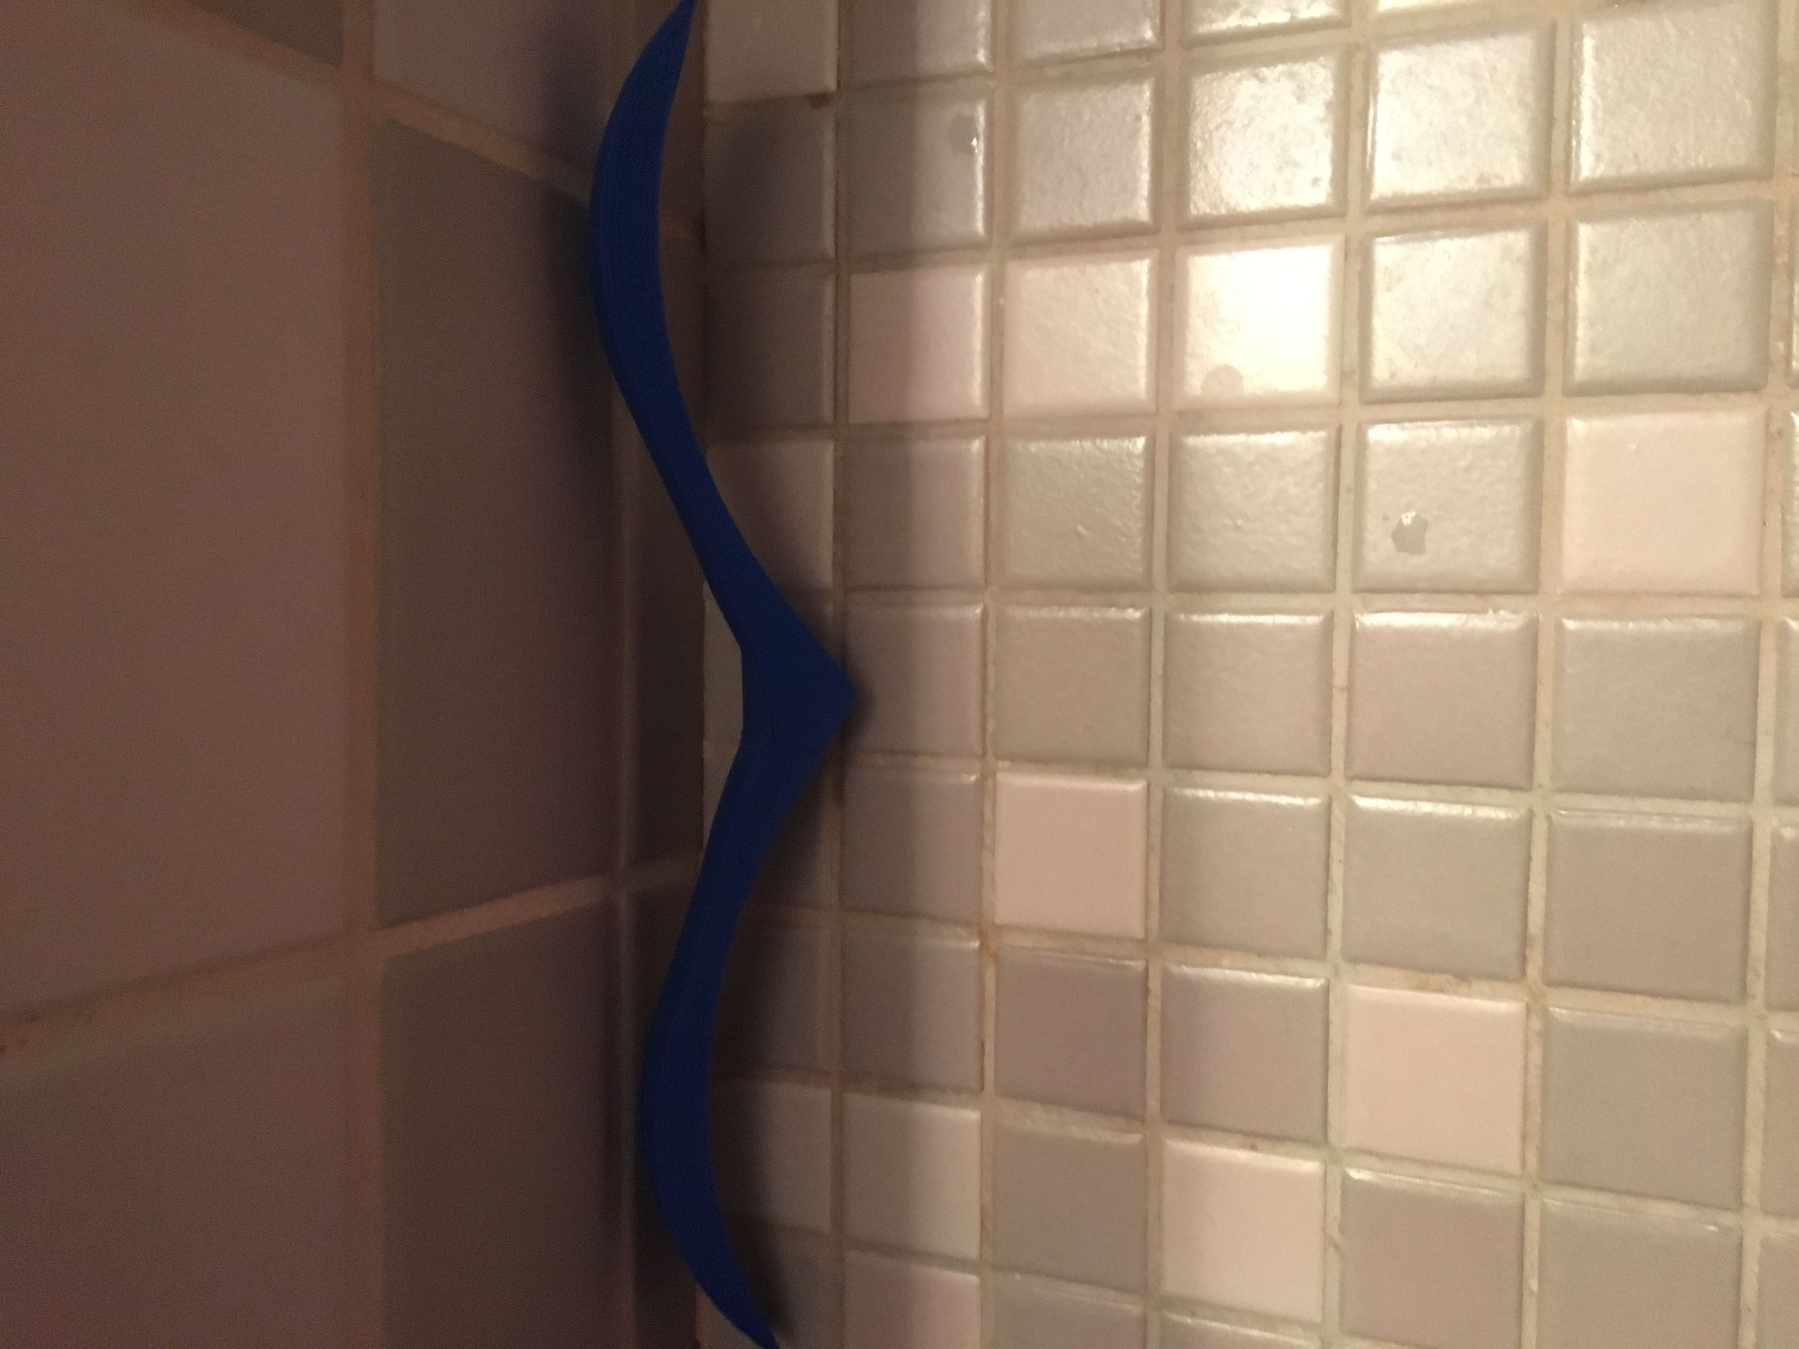Page Holder (In plan)

This seagull shaped thing was created to be a page holder. However, because of it’s size and curve at the bottom of it that never happened. In the positive side it is now a great toy to play, good ornament. While designing this, I thought “M” design was better compared to other things in stopping something which has two sides. So I designed a half “M” and mirrored it. Now this is used as an ornament.